SHARE WITH YOUR CLASSMATES -- Now that you have identified the various components of a computer, it’s time to apply your new learning in a fun and creative way! You will pretend to be one component of a computer and explain in a story how you interact with the other parts of a computer.

* Choose one of the components of a computer
* Tell a creative story from that parts’ perspective or point of view:
  + Explain your role
  + Describe who you live near
  + Discuss who you might work with and how

For example, I might write a story from the perspective of the Motherboard. I would talk about how I am the backbone of the family and it is me that distributes all the power and energy to everyone else. I might highlight that without me there would be no work done.

Share your story with your classmates in any format you wish (you might be thinking about your learning style from the previous activity) You can record your story in a written format, you can enter it as an oral recording or you could create a visual such as a [**Powtoon**](https://www.powtoon.com/home/?). Make sure that if you are doing it in written format, you write it in the word processing format of your choice and then copy and paste it into the discussion. You can also upload your assignment or provide a link depending on the method you choose.

Read all of the discussion post stories. Find two posts with components that are connected to you (as components) and post a comment on each about how the two of you interact and maybe comment on something you learned from their story.

Hi! I’m the CPU. You also might know me by the name of Central Processing Unit. You can find me on the motherboard of your computer. Not every computer’s motherboard is in the same place but wherever your motherboard is, that’s where I’ll be too. I am a small but very mighty computer chip that’s main job is to process information. I usually sit in the middle of the motherboard in my very own CPU socket. I am in the top center of the motherboard, next to the RAM slots. Sometimes, I am called the central processor since I am the most important processor in computers. This is because I consist of multiple processing parts, such as the main memory and control unit, that a computer could not function properly without. You could say that I’m the brain of the computer. I process input instructions and data that is given to me when you are playing games, making documents and searching on the web. Not to brag or anything but without me, computers just wouldn’t work. I was first created in 1971 and ever since then I’ve just been improving more and more. I am so vital to a computer and have one of the most important jobs.

Below, you can see a picture of me:

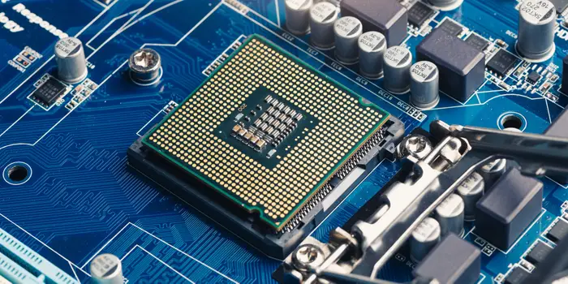

<https://www.businessinsider.com/guides/tech/what-is-a-cpu>

<https://www.hp.com/us-en/shop/tech-takes/what-is-cpu>